P.C. Roberts and D. Stockman

# *On the Brink of War and Economic Collapse — Paul Craig Roberts*

[December 12, 2014](http://www.paulcraigroberts.org/2014/12/12/) |  <http://www.paulcraigroberts.org/2014/12/12/brink-war-economic-collapse-paul-craig-roberts/>

On the Brink of War and Economic Collapse

Paul Craig Roberts

On occasion a reader will ask if I can give readers some good news. The answer is: not unless I lie to you like “your” government and the mainstream media do. If you want faked “good news,” you need to retreat into The Matrix. In exchange for less stress and worry, you will be led unknowingly into financial ruin and nuclear armageddon.

If you want to be forewarned, and possibly prepared, for what “your” government is bringing you, and have some small chance of redirecting the course of events, read and support this site. It is your site. I already know these things. I write for you.

The neoconservatives, a small group of warmongers strongly allied with the military/industrial complex and Israel, gave us Granada and the Contras affair in Nicaragua. President Reagan fired them, and they were prosecuted, but subsequently pardoned by Reagan’s successor, George H.W. Bush.

Ensconced in think tanks and protected by Israeli and military/security complex money, the neoconservatives reemerged in the Clinton administration and engineered the breakup of Yugoslavia, the war against Serbia, and the expansion of NATO to Russia’s borders.

Neoconservatives dominated the George W. Bush regime. They controlled the Pentagon, the National Security Council, the Office of the Vice President, and much else. Neoconservatives gave us 9/11 and its coverup, the invasions of Afghanistan and Iraq, the beginning of the destabilizations of Pakistan and Yemen, the U.S. Africa Command, the invasion of South Ossetia by Georgia, the demise of the anti-ABM Treaty, unconstitutional and illegal spying on American citizens without warrants, loss of constitutional protections, torture, and the unaccountability of the executive branch to law, Congress, and the judiciary. In short, the neoconservatives laid the foundation for dictatorship and for WW III.

The Obama regime held no one accountable for the crimes of the Bush regime, thus creating the precedent that the executive branch is above the law. Instead, the Obama regime prosecuted whistleblowers who told the truth about government crimes.

Neoconservatives remain very influential in the Obama regime. As examples, Obama appointed neoconservative Susan Rice as his National Security Advisor. Obama appointed neoconservative Samantha Power as U.S. Ambassador to the United Nations. Obama appointed neoconservative Victoria Nuland as Assistant Secretary of State. Nuland’s office, working with the CIA and Washington-financed NGOs, organized the U.S. coup in Ukraine.

Neoconservatism is the only extant political ideology. The ideology is “America uber alles.” Neoconservatives believe that History has chosen the United States to exercise hegemony over the world, thereby making the U.S. “exceptional” and “indispensable.” Obama himself has declared as much. This ideology gives neoconservatives tremendous confidence and drive, just as Karl Marx’s conclusion that history had chosen the workers to be the ruling class gave early communists confidence and drive.

This confidence and drive makes the neoconservatives reckless.

To advance their agenda neoconservatives propagandize the populations of the U.S. and Washington’s vassal states. The presstitutes deliver the neoconservatives’ lies to the unsuspecting public: Russia has invaded and annexed Ukrainian provinces; Putin intends to reconstitute the Soviet Empire; Russia is a gangster state without democracy; Russia is a threat to the Baltics, Poland, and all of Europe, necessitating a U.S./NATO military buildup on Russia’s borders; China, a Russian ally, must be militarily contained with new U.S. naval and air bases surrounding China and controlling Chinese sea lanes.

The neoconservatives and President Obama have made it completely clear that the U.S. will not accept Russia and China as sovereign countries with economic and foreign policies independent of the interests of Washington. Russia and China are acceptable only as vassal states, like the UK, Europe, Japan, Canada, and Australia.

Clearly, the neoconservative formula is a formula for the final war.

All of humanity is endangered by a handful of evil men and women ensconced in positions of power in Washington.

Anti-Russia propaganda has gone into high gear. Putin is the “new Hitler.”  
Daniel Zubov reports on a joint conference held by three U.S. think tanks.  
The conference blamed Russia for the failures of Washington’s foreign policy. Read this article:<http://sputniknews.com/columnists/20141205/1015538604.html>to see how neoconservatives operate in order to control the explanations. Even Henry Kissinger is under attack for stating the obvious truth that Russia has a legitimate interest in Ukraine, a land long part of Russia and located in Russia’s legitimate sphere of influence.

Since the Clinton regime, Washington has been acting against Russian interests. In his forthcoming book, The Globalization of War: America’s Long War against Humanity, Professor Michel Chossudovsky presents a realistic appraisal of how close Washington has brought the world to its demise in nuclear war. This passage is from the Preface:

“The ‘globalization of war’ is a hegemonic project. Major military  
and covert intelligence operations are being undertaken  
simultaneously in the Middle East, Eastern Europe, sub-Saharan  
Africa, Central Asia and the Far East. The US military agenda  
combines both major theater operations as well as covert actions  
geared towards destabilizing sovereign states.

“Under a global military agenda, the actions undertaken by the  
Western military alliance (US-NATO-Israel) in Afghanistan, Pakistan,  
Palestine, Ukraine, Syria and Iraq are coordinated at the highest  
levels of the military hierarchy. We are not dealing with  
piecemeal military and intelligence operations. The July-August  
2014 attack on Gaza by Israeli forces was undertaken in close consultation  
with the United States and NATO. In turn, the actions in  
Ukraine and their timing coincided with the onslaught of the attack  
on Gaza.

“In turn, military undertakings are closely coordinated with a  
process of economic warfare which consists not only in imposing  
sanctions on sovereign countries but also in deliberate acts of destabilization  
of financial and currency markets, with a view to undermining  
the enemies’ national economies.

“The United States and its allies have launched a military adventure  
which threatens the future of humanity. As we go to press, US  
and NATO forces have been deployed in Eastern Europe. US military  
intervention under a humanitarian mandate is proceeding in sub-Saharan  
Africa. The US and its allies are threatening China under President Obama’s  
‘Pivot to Asia’.

“In turn, military maneuvers are being conducted at Russia’s  
doorstep which could lead to escalation.

“The US airstrikes initiated in September 2014 directed against  
Iraq and Syria under the pretext of going after the Islamic State are  
part of a scenario of military escalation extending from North Africa  
and the Eastern Mediterranean to Central and South Asia.  
The Western military alliance is in an advanced state of readiness.

“And so is Russia.”

As I have often remarked, Americans are an insouciant people. They are simply unaware. Suppose they were aware, suppose that the entire population understood the peril, could anything be done, or have the insouciant Americans fallen under the control of the police state that Washington has created?

I don’t think there is much hope from the American people. The American people cannot tell genuine from fake leadership, and the ruling private elites will not permit real leaders to emerge. Moreover, there is no organized movement in opposition to the neoconservatives.

The hope comes from outside the political system. The hope is that the House of Cards and rigged markets erected by policymakers for the benefit of the One Percent collapses. David Stockman regards this outcome as a highly likely one. The collapse that Stockman sees as being on its way is the same collapse about which I have warned. Moreover, the number of Black Swans which can originate collapse are even more numerous than the ones Stockman correctly identifies. Some financial organizations are worried about a lack of liquidity in the fixed income (bonds) and derivatives markets. Barbara Novack, co-chair of Black Rock, is lobbying hard for a derivatives bailout mechanism.

David Stockman’s article [below] is important. Read it until you understand it, and you will know more than most everyone. <http://www.lewrockwell.com/2014/12/david-stockman/duck-and-cover%E2%80%A8/>

Many will ask: If the wealth of the One Percent is vulnerable to economic collapse, will war be initiated to protect this wealth and to blame the Russians or Chinese for the hardships that engulf the American population? My answer is that the kind of collapse that I expect, and that David Stockman and no doubt others expect, presents government with such social, political, and economic insecurity that organizing for a major war becomes impossible.

Whereas the political impotence of the American people and the vassalage of the Western World impose no constraints on Washington, economic collapse brings revolutions and the demise of the existing order.

As hard as collapse would make it for people to survive, the chances for survival are higher than in the event of nuclear war.

# Duck And Cover——-The Lull Is Breaking, The Storm Is Nigh

## by [David Stockman](http://davidstockmanscontracorner.com/author/stockdav/) • December 10, 2014 <http://davidstockmanscontracorner.com/duck-and-cover-the-lull-is-breaking-the-storm-is-nigh/>

September 15, 2008 is the day that Lehman died and the moment that the world’s central banks led by the Fed went all-in. As it has turned out, that was an epochal leap into the most dangerous monetary deformation that the world has ever known.

It needn’t have been. What was really happening at this pregnant moment was that the remnants of honest capital markets were begging for a purge and liquidation of the speculative rot that had built up during the Greenspan era. But the phony depression scholar running the Fed, Ben Bernanke, would have none of it. So he falsely whooped-up a warning that Great Depression 2.0 was at hand—-sending Washington, Wall Street and the rest of the world into an all-out panic.

The next day’s AIG crisis quickly became ground zero—the place where the entire fraudulent narrative of systemic “contagion” was confected. Yet that needn’t have been, either. In truth, AIG was not the bearer of a mysterious financial contagion that had purportedly arrived on a comet from deep space.

***As subsequent history has now proven, AIG’s $800 billion globe spanning balance sheet at the time was perfectly solvent at the subsidiary level.***Not a single life insurance contract, P&C cover or retirement annuity anywhere in the world was in jeopardy on the morning of September 16th.

The only thing gone awry was that the London-based CDS (credit default swap) operation of AIG’s holding company was monumentally illiquid. Joseph Cassano and the other latter-day geniuses who were running it had spent two decades picking up nickels (CDS premium) in front of a steamroller, while booking nearly the entirety of these winnings as profits—all to the greater good of their fabulous bonuses.

But now, as the underlying securitized mortgage market imploded, they needed to meet huge margin calls on insurance contracts they had written against mortgage CDOs. In truth, however, the whole mountain of CDS was bogus insurance because AIG’s holding company did not have a legal call on the hundreds of billions of cash and liquid assets ensconced in dozens of its major subsidiaries.

From a legal and cash flow point of view, Hank Greenberg’s mighty insurance empire was essentially a mutual fund. Cassano and his posse had been implicitly pledging assets (via AIG’s corporate or consolidated AAA rating) that belonged to someone else—-namely, the insurance subsidiaries and the state insurance commissioners who effectively controlled them.

***Yet this scandalous fact was not a world crisis, nor really any crisis at all.*** Yes, the several hundred billions of CDS contracts sold by the Cassano London operation were bogus and could not be paid off—–since the holding company had no available liquid capital. Nevertheless, they had been purchased almost entirely by a dozen or so of the largest banks in the world, including Deutsche Bank, Barclays, Societe Generale, Bank of America/Merrill Lynch and Goldman Sachs, to name a few of the usual suspects. And as I documented in ***The Great Deformation,***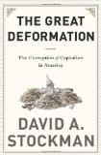these banks could have readily afforded the hit on the underlying CDOs—– and  they deserved it,too.

As to the former point, the combined balance sheet of the impacted big banks was about***$20 trillion at the time***, and the  potential loss on the CDS contracts that AIG’s holding company could not fund was perhaps $80 billion at the outside. After all, most of the CDO paper which these mega-banks had purchased and then magically transformed into AAA credits (and thereby could hold without posting a dime of capital) consisted of the so-called “super-senior” tranches. The really nasty crud at the bottom of the CDO capital structures—which did generate deep losses—- had been pawned off to institutional investors and trust funds for Norwegian fishing villages and the like.

So the day of reckoning for AIG’s CDS fraud presented no danger to the world’s banking system. ***The loss might have amounted to 0.5% of their combined footings—–a one-time hit that Wall Street brokers would have counseled to ignore and which might have zapped banker bonuses for the next year or even less.***

And those foolish bankers did need to be punished for negligence, stupidity and unseemly greed. In point of fact, Cassano was never indicted for his bulging book of bogus CDS insurance because it amounted to fraud in plain sight. Any one who read AIG’s 10K could have seen that the consolidated balance sheet of AIG was riddled with dividend stoppers and capital conservation limits imposed by the insurance regulators at the subsidiary level. Cassano never, ever had the cash to meet margin calls or pay-off the supposedly remote risk of actual claims; his policies had been purchased all along by the proverbial greater fools.

But this calamity of stupidity and negligence has turned out to be a really big thing in the history of the modern financial era; it was indeed the Rubicon. By falsely transforming a negligible hit to the balance sheet of the world’s mega-banks—-most of which were quasi-socialist institutions in Europe and would have been bailed out by their governments anyway—-into the alleged collapse of the mighty AIG,  Secretary Paulson, Bernanke and their cabal of Wall Street henchman opened the door in one fell swoop to the present global monetary madness.

At that fraught moment in time, AIG was the financial gold standard—–the massive AAA balance sheet that anchored the entire financial market. So when out of the blue—literally without even a few days notice to even the attentive public—–it had apparently descended into a $180 billion black hole, the myth of systemic breakdown and all-consuming financial “contagion” was not only born; it gained instant resonance throughout Wall Street and Washington.

The rest is history, as they say. And what a fantastic, but lamentable history it was. Owing to the cursed recency bias that now animates the mainstream narrative, it has already been forgotten that today’s elephantine central bank balance sheets did not remotely exist just six years ago. Indeed, they could not have been imagined back then—not even by Bernanke himself.

But upon the eruption of the AIG catalyst, the mad money printing dash was on. As shown below, it had taken the first 94 years of the Fed’s existence to grow its balance sheet footings to $900 billion—-something achieved by steadily plucking new credits out of thin air over the years and decades. But within six weeks of the so-called AIG meltdown, Bernanke had replicated what had taken his predecessors nigh on to a century to accomplish.

And then he didn’t stop. Fighting the fabricated enemy of “contagion” and thereby thwarting Wall Street’s desperate need for a cleansing financial enema, he had nearly tripled the Fed’s historic balance sheet by year-end 2008, and on it went from there.

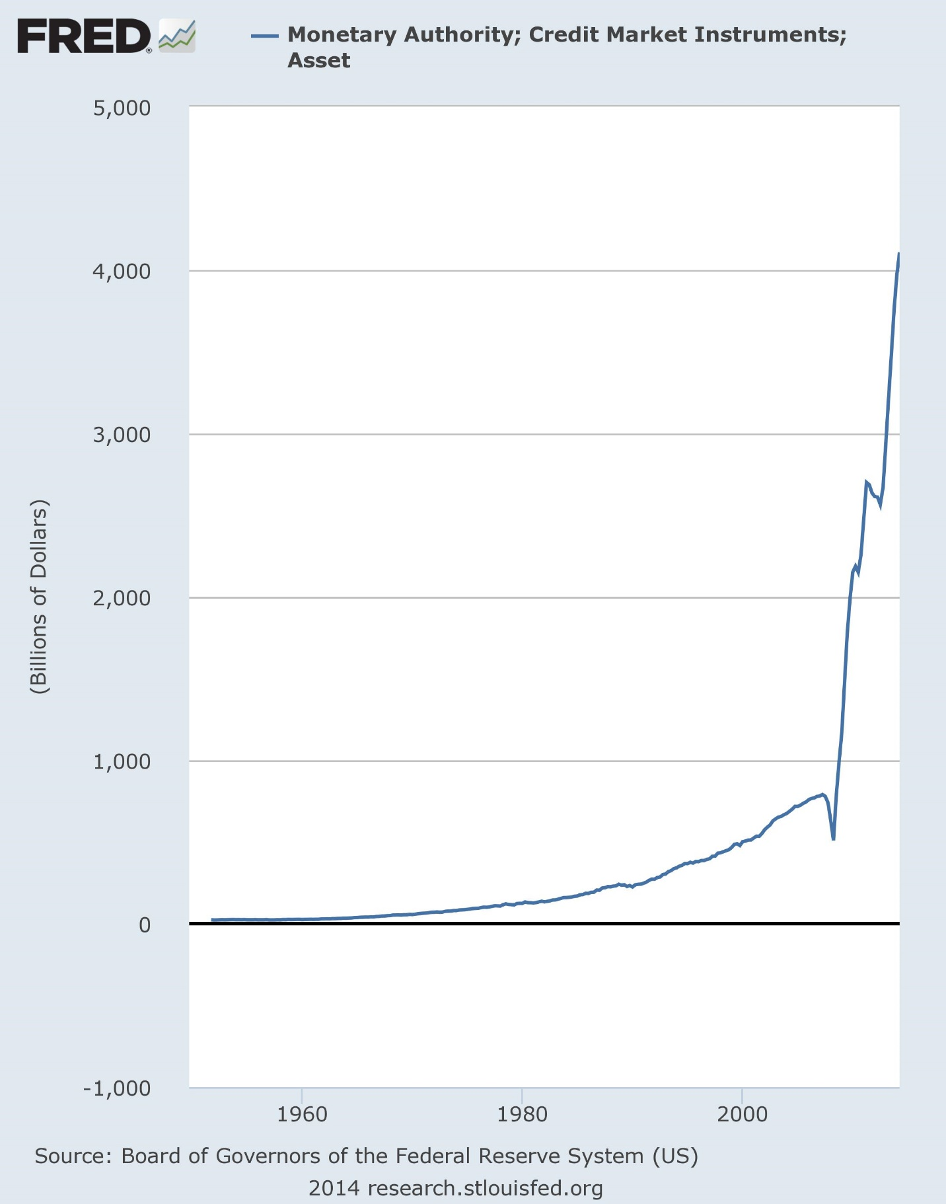

And of course it was not just the Fed running the printing presses red hot. Owing to both Keynesian ideology and defensive necessity, the other major central banks of the world followed suit. At the time of the crisis, the combined balance sheet of the Fed, ECB and BOJ was $3.5 trillion or about 11% of GDP. In short order that number will reach $11 trillion and 30% of the combined GDP of the so-called G-3.

Throw in the BOE, the People’s Printing Press of China, the bloated central banks of the oil exporters and Russia and assorted others like the reserve banks of India and Australia and you have total central banks footings in excess of $16 trillion or roughly triple the pre-crisis level.

[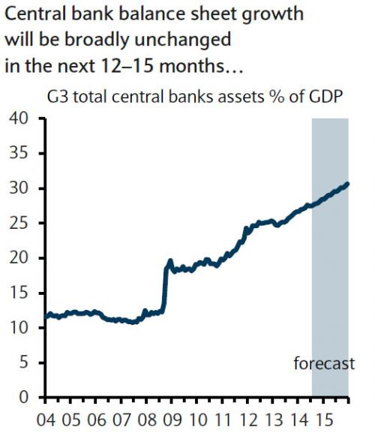](http://www.zerohedge.com/sites/default/files/images/user5/imageroot/2014/09/CB%20future.jpg)

This tsunami of central bank credit did little for the real economy in places where the private sector was already at “peak debt” such as the US and Europe; and it did fuel one final blast of the malinvestment boom in places that still had balance sheet runway available like China, Brazil and much of the rest of the EM world.

But what it did do universally and thunderously was to fuel a financial asset inflation the likes of which the world had never before seen.

Prior to their recent stumble, the combined equity markets of the world had reached a capitalization of nearly $75 trillion compared to barely $25 trillion at the dark bottom in March 2009. And, yes, $50 trillion of gain in a comparative historical heartbeat did wonders for the net worth of the global 1%.

But it also did something else; it destroyed the remaining vestiges of financial market stability and honest price discovery. After 6-years of the central bank tsunami, two-way markets were gone; the shorts were dead; skeptics were out of business; greybeard investors had retired; speculators regularly bought downside “protection” (i.e. puts on the S&P 500) for chump change; and the law of “buy the dips” became unassailable.

***Even more crucially, capital markets were transformed into rank casinos that were virtually devoid of all economic information……except, except the word clouds, leaks and sound bites of central bank speakers and their tools in the press and monitors in the banks, brokerage houses and hedge funds.*** At length, this meant that the only reason to buy was that virtually every risk asset class was rising; and it also meant that the only risk worth worrying about in a day-trading market was from the verbal emissions of central bankers and their Wall Street accomplices and stooges.

So as long as the central bank con job lasted, there was no reason not to buy, buy, buy. [BTFD] The financial world’s greatest clown, Jim Cramer of CNBC, became a prophet in his own time. Indeed, the man’s stupendous insouciance became embedded in the casino itself.

And the VIX is the smoking gun of proof. Over the span of approximately 72 months, the world’s raging central bankers simply drove risk right out of the casino.

[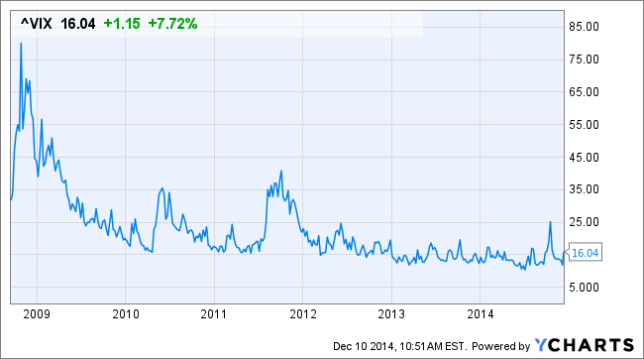](http://ycharts.com/indices/%5eVIX/chart/#/?startDate=9/15/2008&endDate=&format=real&calcs=&zoom=custom&securities=include:true,id:^VIX,,&quotes=true&units=&maxPoints=650&splitType=single)

Except they didn’t actually banish financial risk; they just drove it underground. When every financial asset is rising, the casino creates its own marginable collateral. Yesterday’s gain becomes tomorrow’s repo and re-hypothecated security against the next day’s round of buying. And as long as asset values are inflating, the inherent risk in these daisy chains is muffled and discounted.

Yet that’s exactly why the present mother of all financial bubbles is so dangerous and palpably unstable. The marginal “bid” is dependent upon wildly inflated collateral which is tucked away in the warp and woof of the entire global financial system. When the Chinese stock market hit a 5.5% air pocket within a few minutes two nights ago, for example, it was because the financial authorities there said icksnay to the repo of bonds issued by essentially bankrupt local development agencies.

Stated differently, there are financial time bombs planted everywhere in the world economy because central bank financial repression has caused drastic mispricing of nearly every class of financial asset, which is to say, every layer of collateral which has ratcheted-up the entire edifice.

As the redoubtable Ambrose Evans-Prichard so cogently noted, central bank ZIRP has radically compressed the debt markets of the world. This means that cap rates—-the basis for valuation of tens of trillions of fixed income securities and real estate around the world—are now so aberrantly low as to be downright stupid:

What is clear is that the world has become addicted to central bank stimulus. **Bank of America said 56pc of global GDP is currently supported by zero interest rates, and so are 83pc of the free-floating equities on global bourses. Half of all government bonds in the world yield less that 1pc.**Roughly 1.4bn people are experiencing negative rates in one form or another.

Needless to say, this drastic central bank driven financial repression has unleashed a mindless pursuit of “yield” or short-term trading gains that give the concept of “irrational exuberance” an entirely new definition. Consider for example, the hapless mutual fund investors or institutional managers who have been buying energy sector CLOs. What is the collateral for the 5% yields advertised by these fly-by-night funds—–often issued and managed by the same folks who sold housing sector CLOs and CDOs last time around?

Why it’s the leveraged loans issued by E&P operators in the shale patches. The collateral for these leveraged loans, in turn, is shale rocks 4,000-9,000 feet down under that have been worthless until approximately 2005 and would be worthless today without dramatically over-priced crude oil and drastically underpriced debt capital.

That is to say, the vaunted collateral in the shale patch craps out after about two-years unless new money is poured down the well bore and oil prices are above $75-$80 per barrel on the WTI marker price to cushion the sharp discounts back to the wellhead. But with marker price now plunging into the $50s, the drilling will soon stop, the production will crap-out, the shale rock collateral value will regress toward the zero bound, the E&P borrowers will default, the energy CLO’s will implode and the hapless yield chasers will be left high, dry and panicked.

Cannot the same thing be said of Italian bonds at 2%? As reminded below, the Italian economy has not grown for six years, its debt-to-GDP ratio has gone critical and its political system is disintegrating.

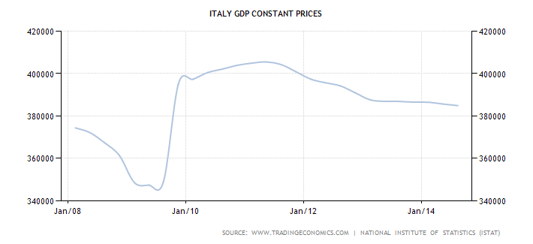

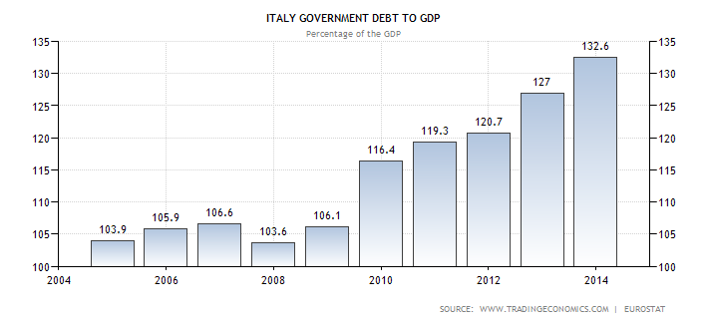

So from whence did the “bid” arise after Draghi’s “whatever it takes” [ukase](http://en.wikipedia.org/wiki/Ukase), which in just 24 months drove the yield on this sovereign junk from 7% to 2%?

Well, it came from its own bootstraps, that’s what. The front-running speculators who backed up their trucks to Draghi’s pronouncement where not sitting on a pile of cash looking for “value”.  Instead, they bought a pile of Italian bonds and then margined their purchases in the repo market. Yes, central bank ZIRP means essentially zero cost of carry; its the source of the bid that never asks whether 2% is enough. When bonds are held by the day or even hour, it’s far more than enough as long as the repo can be rolled and bond prices keep inflating.

Until they don’t. Are the international dollar bonds of Turkish banks—one example of the $9 trillion EM debt market—– issued against their loan books any different? Just consider the daisy chain of collateral there. Istanbul is comprised of miles of empty apartment and commercial buildings which are collateral for the Turkish bank loans. Yet what is the equity of the real estate developer borrowers of these generously leveraged loans—-other than their “investments” in the Erdogan regime?  More often than not it’s the down-payments on newly built space made by speculators who borrowed the money from the very same banks.

Indeed, in a ZIRP world the collateral chains extend so deep into the netherworld of speculation that no one can possibly trace them. That is, until after they erupt. Then we will learn all about the “risk” that was driven below the surface during the great bubble of the past 6 years just like we did in September 2008.

In short, what is happening now is that risk is coming out of hiding; the collateral chains are buckling; the financial time bombs are beginning to explode.

There is nothing especially ***new***about this development—its the third occurrence this century. But there is possibly something ***different***  this time around the block.

This time the carnage could be much worse because the most recent tsunami of central bank credit was orders of magnitude larger and more virulent than during the run-up to the Lehman event or the dotcom implosion.

Moreover, the central banks are now out of dry powder—– impaled on the zero-bound. That means any resort to a massive new round of money printing can not be disguised as an effort to “stimulate” the macro-economy by temporarily driving interest rates to “extraordinarily” low levels. They are already there.

Instead, a Bernanke style balance sheet explosion like that which stopped the financial meltdown in the fall and winter of 2008-2009 will be seen for exactly what it is—-an exercise in pure monetary desperation and quackery.

So duck and cover. This storm could be a monster.